Brittiney Sempasa

862155631

EE120A Section 21

Mini-Project: Traffic Light Controller

Ruth Navarrete

Overview:

In this project we will use RTL design methodology to design and implement a digital design for a 4-way traffic signal controller. Our goal is to create a stop light controller for a corner where two streets cross. A walker should be able to press a button and then, after the current state of the lights finishes, all lights should be in a red state for five seconds, allowing the walker to cross.

New concepts:

Register Transfer Level (RTL) design - is a method in which we can transfer data from one register to another orconstructing a digital design using Combinational and Sequential circuits in HDL like Verilog or VHDL which can model logical and hardware operation.

Analysis:

**BASIC DESIGN:**

High-Level State Machine

    Inputs: b(button), T(timer)

    Outputs: light1, light2, light_w

    Local registers: b_reg

|  |
| --- |
| b’T |

P1_ON

P1_INIT

|  |
| --- |
| b’T |

|  |
| --- |
| light1: 0 light2: 0  light_w:0  reset: 1  cnt_rst: 0  cnt_int:0  b_reg = 0 |

|  |
| --- |
| light1: 1 light2: 0  light_w: 0  reset: 0  cnt_rst: 3  cnt_int: 0  b_reg = b_reg+b |

START

P2_INIT

|  |
| --- |
| light1: 0 light2: 0  light_w:0  reset: 1  cnt_rst: 1  cnt_int: 0  b_reg = 0 |

|  |
| --- |
| light1: 0 light2: 0  light_w:0  reset: 1  cnt_rst: 0  cnt_int:0  b_reg = 0 |

|  |
| --- |
| b’T |

|  |
| --- |
| T |

|  |
| --- |
| bT |

|  |
| --- |
| T’ |

|  |
| --- |
| b’T’ |

WALK_ON

WALK_INIT

P2_ON

|  |
| --- |
| bT |

|  |
| --- |
| light1: 0 light2: 0  light_w: 0  reset: 1  cnt_rst: 0  cnt_int:0  b_reg =0 |

|  |
| --- |
| light1: 0 light2: 1  light_w:0  reset: 0  cnt_rst: 3  cnt_int: 0b_reg = b_reg+b |

|  |
| --- |
| light1: 0 light2: 0  light_w: 1  reset: 0  cnt_rst: 5  cnt_int:0  b_reg = b_reg+b |

Finite State Machine

Inputs: b(button), clk(clock)

Outputs: light1, light2, light_w, b_cl, b_ld

P1_ON

(001)

P1_INIT

(000)

(o

|  |
| --- |
| b’(T) |

|  |
| --- |
| light1: 0 light2: 0  light_w: 0  b_cl = 1  b_ld= 0 |

|  |
| --- |
| light1: 1 light2: 0  light_w: 0  b_cl = 0  b_ld= 1 |

START

P2_INIT

(010)

|  |
| --- |
| light1: 0 light2: 0  light_w: 0  b_cl = 1  b_ld= 0 |

|  |
| --- |
| light1: 0 light2: 0  light_w: 0  b_cl = 1  b_ld= 0 |

|  |
| --- |
| b(T) |

|  |
| --- |
| T |

|  |
| --- |
| b’(T) |

|  |
| --- |
| T’ |

|  |
| --- |
| b’(T)’ |

WALK_ON

(101)

WALK_INIT

(100)

P2_ON

(011)

|  |
| --- |
| light1: 0 light2: 0  light_w: 0  b_cl = 1  b_ld= 0 |

|  |
| --- |
| light1: 0 light2: 1  light_w: 0  b_cl = 0  b_ld= 1 |

|  |
| --- |
| light1: 0 light2: 0  light_w: 1  b_cl = 0  b_ld= 1 |

|  |
| --- |
| b(T) |

**ADDITIONAL FEATURES:**

High-Level State Machine

    Inputs: b1(button),b2(button), T(timer)

    Outputs: light1(east/west lights), light2(north/south lights), light_w, light_t1(east/west/walk lights), light_2(north/south/walk light)

    Local registers: b_reg1, b_reg2

|  |
| --- |
| (b1)’(b2)’T’ |

P1_ON

P1_INIT

|  |
| --- |
| (b1)’(b2)T |

|  |
| --- |
| (b1)’(b2)’T |

|  |
| --- |
| light1: 0 light2: 0  light_w: 1  light_t1:0  light_t2: 1  reset: 0  cnt_rst: 3  cnt_int:0  b_reg1 = b_reg1+b1  b_reg2 = b_reg2+b2 |

|  |
| --- |
| light1: 0 light2: 0  light_w: 0  light_t1:0  light_2: 0  reset: 1  cnt_rst: 0  cnt_int:0  b_reg1 = 0  b_reg2 = 0 |

START

P2_INIT

|  |
| --- |
| light1: 0 light2: 0  light_w: 0  light_t1:0  light_2: 0  reset: 1  cnt_rst: 0  cnt_int:0  b_reg1 = 0  b_reg2 = 0 |

|  |
| --- |
| light1: 0 light2: 0  light_w: 0  light_t1:0  light_2: 0  reset: 1  cnt_rst: 0  cnt_int:0  b_reg1 = 0  b_reg2 = 0 |

|  |
| --- |
| (b1)’(b2)’T |

|  |
| --- |
| T |

|  |
| --- |
| (b1)’(b2)’T |

|  |
| --- |
| (b1)’(b2)’T |

|  |
| --- |
| T’ |

|  |
| --- |
| (b1)’(b2)’T’ |

|  |
| --- |
| T’ |

WALK_ON1

WALK_INIT1

P2_ON

|  |
| --- |
| (b1)(b2)’T’ |

|  |
| --- |
| light1: 0 light2: 0  light_w: 0  light_t1:0  light_t2: 0  reset: 1  cnt_rst: 0  cnt_int:0  b_reg1 = 0  b_reg2 = 0 |

|  |
| --- |
| light1: 0 light2: 0  light_w: 1  light_t1:0  light_t2: 0  reset: 0  cnt_rst: 5  cnt_int:0  b_reg1 = b_reg1+b1  b_reg2 = b_reg2+b2 |

|  |
| --- |
| light1: 0 light2: 0  light_w: 1  light_t1:1  light_t2: 0  reset: 0  cnt_rst: 5  cnt_int:0  b_reg1 = b_reg1+b1  b_reg2 = b_reg2+b2 |

|  |
| --- |
| (b1)’(b2)T |

|  |
| --- |
| light1: 0 light2: 0  light_w: 1  light_t1:0  light_t2: 1  reset: 0  cnt_rst: 5  cnt_int:0  b_reg1 = b_reg1+b1  b_reg2 = b_reg2+b2 |

|  |
| --- |
| light1: 0 light2: 0  light_w: 0  light_t1:0  light_2: 0  reset: 1  cnt_rst: 0  cnt_int:0  b_reg1 = 0  b_reg2 = 0 |

Oranges lines represent transitions to Walk(east/west/walk): (b1)(b2)’T

Blue lines represent transitions to Walk(north/east/walk): (b1)’(b2)T

Finite state machine

Inputs: b1(button),b2(button), clk(clock)

Outputs: light1, light2, light_w, light_t21, light_t2, b_cl1, b_ld1, b_cl2, b_ld2

|  |
| --- |
| (b1)’(b2)’T’ |

P1_ON

P1_INIT

|  |
| --- |
| (b1)’(b2)T |

|  |
| --- |
| (b1)’(b2)’T |

|  |
| --- |
| light1: 1 light2: 0  light_w: 0  light_t1: 0  light_t2: 0  b_cl = 0  b_ld= 1  b_cl = 0  b_ld= 1 |

|  |
| --- |
| light1: 0 light2: 0  light_w: 0  light_t1: 0  light_t2: 0  b_cl = 1  b_ld= 0  b_cl = 1  b_ld= 0 |

START

P2_INIT

|  |
| --- |
| light1: 0 light2: 0  light_w: 0  light_t1: 0  light_t2: 0  b_cl = 1  b_ld= 0  b_cl = 1  b_ld= 0 |

|  |
| --- |
| light1: 0 light2: 0  light_w: 0  light_t1: 0  light_t2: 0  b_cl = 1  b_ld= 0  b_cl = 1  b_ld= 0 |

|  |
| --- |
| (b1)’(b2)’T |

|  |
| --- |
| T |

|  |
| --- |
| (b1)’(b2)’T |

|  |
| --- |
| (b1)’(b2)’T |

|  |
| --- |
| T’ |

|  |
| --- |
| (b1)’(b2)’T’ |

|  |
| --- |
| T’ |

WALK_ON1

WALK_INIT1

P2_ON

|  |
| --- |
| (b1)(b2)’T’ |

|  |
| --- |
| light1: 0 light2: 0  light_w: 0  light_t1: 0  light_t2: 0  b_cl = 1  b_ld= 0  b_cl = 1  b_ld= 0 |

|  |
| --- |
| light1: 0 light2: 1  light_w: 0  light_t1: 0  light_t2: 0  b_cl = 0  b_ld= 1  b_cl = 0  b_ld= 1 |

|  |
| --- |
| light1: 0 light2: 0  light_w: 1  light_t1: 0  light_t2: 1  b_cl = 0  b_ld= 1  b_cl = 0  b_ld= 1 |

|  |
| --- |
| (b1)’(b2)T |

|  |
| --- |
| light1: 0 light2: 0  light_w: 1  light_t1: 0  light_t2: 1  b_cl = 0  b_ld= 1  b_cl = 0  b_ld= 1 |

|  |
| --- |
| light1: 0 light2: 0  light_w: 0  light_t1: 0  light_t2: 0  b_cl = 1  b_ld= 0  b_cl = 1  b_ld= 0 |

|  |
| --- |
| clk |

3

3

s

timer_5

timer_3

timer

B_reg

B_ld

B_cl

Cnt_init

Cnt_rst

reset

clk

TIMER

B_REG

STATE REGISTER

COMBINATIONAL

LOGIC

|  |
| --- |
| b |

CONTROLLER DATAPATH

light_w

light2

light1

n

3

3

s

timer_5

timer_3

timer

Cnt_init

Cnt_rst

reset

clk

STATE REGISTER

COMBINATIONAL

LOGIC

**ADDITIONAL FEATURE:**

Buttons

light1, light2, light_w, light_t1, light_t2

B_ld2

B_cl2

B_reg2

B_reg1

B_cl1

B_ld1

B_REG1

TIMER

B_REG2

clock

TOP LEVEL:

**module crosswalk**#(**parameter** NBITS = 32)

(

input wire b1,

input wire b2,

input wire clk,

output wire light1,

output wire light2,

output wire light_w,

output wire light_t1,

output wire light_t2

)**;**

//internal wires

**wire** s0**;**

**wire** [NBITS-1:0] cnt_ini**;**

**wire** reset**;**

**wire** b_clr1**;**

**wire** b_ld1**;**

**wire** b_clr2**;**

**wire** b_ld2**;**

**wire** timer**;**

**wire** b_reg1**;**

**wire** b_reg2**;**

crosswalk_controller crosswalkcontroller(

.clk(clk),

.timer(timer),

.b_reg1(b_reg1),

.b_reg2(b_reg2),

.cnt_ini(cnt_ini),

.reset(reset),

.b_clr1(b_clr1),

.b_ld1(b_ld1),

.b_clr2(b_clr2),

.b_ld2(b_ld2),

.s0(s0),

.light1(light1),

.light2(light2),

.light_w(light_w),

.light_t1(light_t1),

.light_t2(light_t2)

);

crosswalk_datapath crosswalkdatapath(

.s0(s0),

.cnt_ini(cnt_ini),

.reset(reset),

.clk(clk),

.b_clr1(b_clr1),

.b_ld1(b_ld1),

.b_clr2(b_clr2),

.b_ld2(b_ld2),

.b1(b1),

.b2(b2),

.b_reg1(b_reg1),

.b_reg2(b_reg2),

.timer(timer)

);

CONTROLLER:

**module crosswalk_controller** #(**parameter** NBITS = 32)

(

input wire clk,

input wire b_reg1,

input wire b_reg2,

input wire timer,

output reg s0,

output reg [NBITS-1:0] cnt_ini = 32'h0000,

output reg reset,

output reg b_clr1,

output reg b_ld1,

output reg b_clr2,

output reg b_ld2,

output reg light1,

output reg light2,

output reg light_w,

output reg light_t1,

output reg light_t2

)**;**

**reg** [3:0] current_state**;**

**reg** [3:0] next_state**;**

// --------------------------------------

// Sequential logic

// --------------------------------------

**always** @(posedge clk) **begin**

current_state <= next_state ;

**end**

// --------------------------------------

// Comb. Logic - FSM

// --------------------------------------

localparam START = 4'b0000;

localparam P1_INIT = 4'b0001;

localparam P1_ON = 4'b0010;

localparam P2_INIT = 4'b0011;

localparam P2_ON = 4'b0100;

localparam WALK_INIT_1 = 4'b0101;

localparam WALK_ON_1 = 4'b0110;

localparam WALK_INIT_2 = 4'b0111;

localparam WALK_ON_2 = 4'b1000;

**always** @( current_state ) **begin**

**case** **(**current_state**)**

START **:** begin

light1 = 1'b0**;**

light2 = 1'b0**;**

light_w = 1'b0**;**

light_t1 = 1'b0**;**

light_t2 = 1'b0**;**

s0 = 1'b0**;**

reset = 1'b1**;**

b_clr1 = 1'b1**;**

b_ld1 = 1'b0**;**

b_clr2 = 1'b1**;**

b_ld2 = 1'b0**;**

next_state = P1_INIT**;**

end

P1_INIT **:** begin

light1 = 1'b0**;**

light2 = 1'b0**;**

light_w = 1'b0**;**

light_t1 = 1'b0**;**

light_t2 = 1'b0**;**

s0 = 1'b0**;**

reset = 1'b1**;**

b_clr1 = 1'b1**;**

b_ld1 = 1'b0**;**

b_clr2 = 1'b1**;**

b_ld2 = 1'b0**;**

next_state = P1_ON**;**

end

P1_ON **:** begin

light1 = 1'b1**;**

light2 = 1'b0**;**

light_w = 1'b0**;**

light_t1 = 1'b0**;**

light_t2 = 1'b0**;**

s0 = 1'b0**;**

reset = 1'b0**;**

b_clr1 = 1'b0**;**

b_ld1 = 1'b1**;**

b_clr2 = 1'b0**;**

b_ld2 = 1'b1**;**

if**(**timer&&~b_reg1&&~b_reg2**)** begin

next_state = P2_INIT**;**

end

else if **(**timer&&b_reg1&&~b_reg2**)** begin

next_state = WALK_INIT_1**;**

end

else if **(**timer&&~b_reg1&&b_reg2**)** begin

next_state = WALK_INIT_2**;**

end

else begin

next_state = P1_ON**;**

end

end

P2_INIT **:** begin

light1 = 1'b0**;**

light2 = 1'b0**;**

light_w = 1'b0**;**

light_t1 = 1'b0**;**

light_t2 = 1'b0**;**

s0 = 1'b0**;**

reset = 1'b1**;**

b_clr1 = 1'b1**;**

b_ld1 = 1'b0**;**

b_clr2 = 1'b1**;**

b_ld2 = 1'b0**;**

next_state = P2_ON**;**

end

P2_ON **:** begin

light1 = 1'b0**;**

light2 = 1'b1**;**

light_w = 1'b0**;**

light_t1 = 1'b0**;**

light_t2 = 1'b0**;**

s0 = 1'b0**;**

reset = 1'b0**;**

b_clr1 = 1'b0**;**

b_ld1 = 1'b1**;**

b_clr2 = 1'b0**;**

b_ld2 = 1'b1**;**

if**(**timer&&~b_reg1&&~b_reg2**)** begin

next_state = P1_INIT**;**

end

else if **(**timer&&b_reg1&&~b_reg2**)** begin

next_state = WALK_INIT_1**;**

end

else if **(**timer&&~b_reg1&&b_reg2**)** begin

next_state = WALK_INIT_2**;**

end

else begin

next_state = P2_ON**;**

end

end

WALK_INIT_1 **:** begin

light1 = 1'b0**;**

light2 = 1'b0**;**

light_w = 1'b0**;**

light_t1 = 1'b0**;**

light_t2 = 1'b0**;**

s0 = 1'b1**;**

reset = 1'b1**;**

b_clr1 = 1'b1**;**

b_ld1 = 1'b0**;**

b_clr2 = 1'b1**;**

b_ld2 = 1'b0**;**

next_state = WALK_ON_1**;**

end

WALK_ON_1 **:** begin

light1 = 1'b0**;**

light2 = 1'b0**;**

light_w = 1'b1**;**

light_t1 = 1'b1**;**

light_t2 = 1'b0**;**

s0 = 1'b1**;**

reset = 1'b0**;**

b_clr1 = 1'b0**;**

b_ld1 = 1'b1**;**

b_clr2 = 1'b0**;**

b_ld2 = 1'b1**;**

if **(**timer**)** begin

next_state = P1_INIT**;**

end

else begin

next_state = WALK_ON_1**;**

end

end

WALK_INIT_2 **:** begin

light1 = 1'b0**;**

light2 = 1'b0**;**

light_w = 1'b0**;**

light_t1 = 1'b0**;**

light_t2 = 1'b0**;**

s0 = 1'b1**;**

reset = 1'b1**;**

b_clr1 = 1'b1**;**

b_ld1 = 1'b0**;**

b_clr2 = 1'b1**;**

b_ld2 = 1'b0**;**

next_state = WALK_ON_2**;**

end

WALK_ON_2 **:** begin

light1 = 1'b0**;**

light2 = 1'b0**;**

light_w = 1'b1**;**

light_t1 = 1'b0**;**

light_t2 = 1'b1**;**

s0 = 1'b1**;**

reset = 1'b0**;**

b_clr1 = 1'b0**;**

b_ld1 = 1'b1**;**

b_clr2 = 1'b0**;**

b_ld2 = 1'b1**;**

if **(**timer**)** begin

next_state = P1_INIT**;**

end

else begin

next_state = WALK_ON_2**;**

end

end

**default:** begin

light1 = 1'b0**;**

light2 = 1'b0**;**

light_w = 1'b0**;**

light_t1 = 1'b0**;**

light_t2 = 1'b0**;**

s0 = 1'b0**;**

reset = 1'b1**;**

b_clr1 = 1'b1**;**

b_ld1 = 1'b0**;**

b_clr2 = 1'b1**;**

b_ld2 = 1'b0**;**

next_state = P1_INIT**;**

end

**endcase**

**end**

endmodule

DATAPATH:

**module crosswalk_datapath** #(**parameter** NBITS = 32)

(

input wire s0,

input wire [NBITS-1:0] cnt_ini,

input wire reset,

input wire clk,

input wire b_clr1,

input wire b_ld1,

input wire b1,

input wire b_clr2,

input wire b_ld2,

input wire b2,

output wire timer,

output wire b_reg1,

output wire b_reg2

)**;**

**reg** [31:0] t3 = 32'h8f0d180**;**

**reg** [31:0] t5 = 32'hee6b280**;**

**wire** [NBITS-1:0] cnt_rst**;**

// --------------------------------------

// B_reg1

// ---------------------------------------

b_reg1 breg1(

.b_clr1(b_clr1),

.b_ld1(b_ld1),

.b1(b1),

.clk(clk),

.b_reg1(b_reg1)

);

// --------------------------------------

// B_reg2

// ---------------------------------------

b_reg2 breg2(

.b_clr2(b_clr2),

.b_ld2(b_ld2),

.b2(b2),

.clk(clk),

.b_reg2(b_reg2)

);

// --------------------------------------

// MUX

// --------------------------------------

crosswalk_mux crosswalkmux(

.s0(s0),

.t3(t3),

.t5(t5),

.cnt_rst(cnt_rst)

);

// --------------------------------------

// Timer instantiation

// --------------------------------------

timer_bh timerbh(

.reset(reset),

.clk(clk),

.cnt_ini(cnt_ini),

.cnt_rst(cnt_rst),

.timer(timer)

);

endmodule

B_REGISTER_1:

**module b_reg1** #(**parameter** NBITS = 32)

(

input wire b_clr1,

input wire b_ld1,

input wire b1,

input wire clk,

output reg b_reg1

)**;**

**always**@(posedge clk) **begin**

**if**(b_clr1)**begin**

b_reg1 = 0;

**end**

**else** **if**(b_ld1) **begin**

b_reg1 = b_reg1 + b1;

**end**

**else** **begin**

b_reg1 = b_reg1;

**end**

**end**

endmodule

B_REGISTER_2:

**module b_reg2** #(**parameter** NBITS = 32)

(

input wire b_clr2,

input wire b_ld2,

input wire b2,

input wire clk,

output reg b_reg2

)**;**

**always**@(posedge clk) **begin**

**if**(b_clr2)**begin**

b_reg2 = 0;

**end**

**else** **if**(b_ld2) **begin**

b_reg2 = b_reg2 + b2;

**end**

**else** **begin**

b_reg2 = b_reg2;

**end**

**end**

endmodule

MUX:

**module crosswalk_mux** #(**parameter** NBITS = 32)

(

input wire s0,

input wire [NBITS-1:0] t3,

input wire [NBITS-1:0] t5,

output reg [NBITS-1:0] cnt_rst

)**;**

**always**@(s0) **begin**

**case(**s0**)**

1'b0 **:** begin

cnt_rst = t3**;**

end

1'b1 **:** begin

cnt_rst = t5**;**

end

**default** **:** begin

cnt_rst = t3**;**

end

**endcase**

**end**

endmodule

TIMER:

**module timer_bh** (

**input** wire clk,

input wire reset,

input wire [31:0] cnt_ini,

input wire [31:0] cnt_rst,

output reg timer

)**;**

**reg** [31:0] count = 32'h0000**;**

**always**@(posedge clk) **begin**

**if**(reset)**begin**

count = cnt_ini;

timer = 1'b0;

**end**

**else** **if** (count == cnt_rst) **begin**

count = cnt_ini;

timer = 1'b1;

**end**

**else** **begin**

count = count + 1;

timer = 1'b0;

**end**

**end**

endmodule

TESTBENCH:

**module crosswalk1_tb**;

// Inputs

**reg** b1**;**

**reg** b2**;**

**reg** clk**;**

// Outputs

**wire** light1**;**

**wire** light2**;**

**wire** light_w**;**

**wire** light_t1**;**

**wire** light_t2**;**

// Instantiate the Unit Under Test (UUT)

crosswalk uut (

.b1(b1),

.b2(b2),

.clk(clk),

.light1(light1),

.light2(light2),

.light_w(light_w),

.light_t1(light_t1),

.light_t2(light_t2)

);

initial **begin**

clk = 0;

forever **begin**

#50 clk = ~clk;

**end**

**end**

initial **begin**

b1 = 0;

forever **begin**

#50 b2 = ~b2;

**end**

**end**

initial **begin**

b2 = 0;

forever **begin**

#50 b2 = ~b2;

**end**

**end**

**endmodule**

Records:

ADDITIONAL FEATURES:

TOP LEVEL RTL:

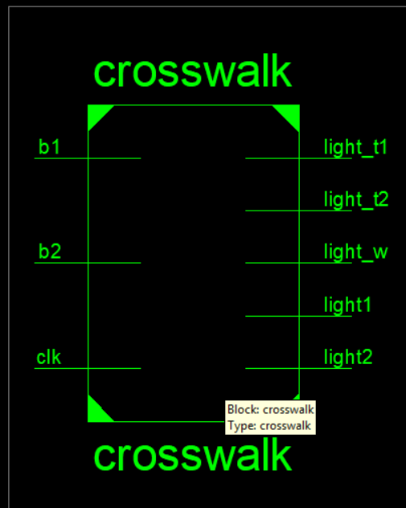

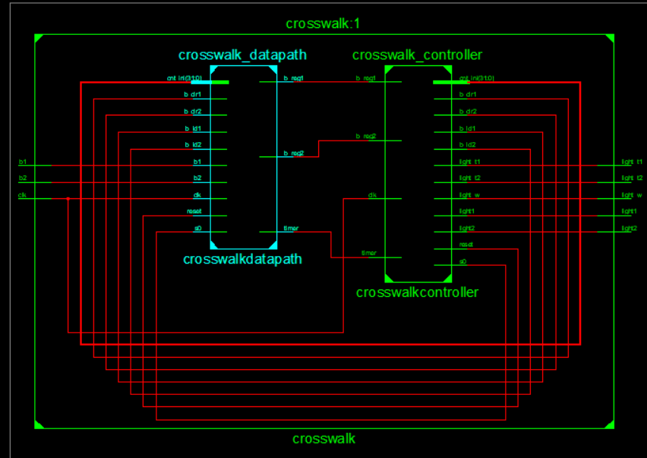

TESTBENCH WAVEFORM:

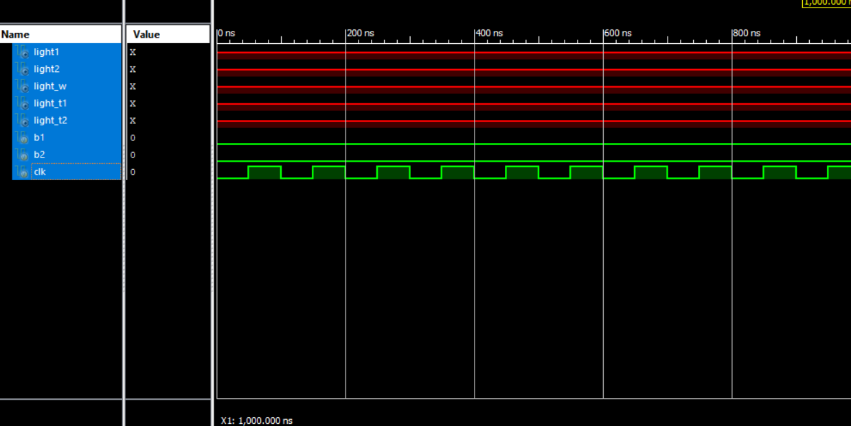

Youtube demonstration:

<https://www.youtube.com/watch?v=JbVC-KpRia4>

Discussion:

By far the most difficult part of the mini-project was understanding how to implement the state machine onto Xilinx. We approached the project as a coding assignment rather than wiring components to ports. It grew easier if we just knew what each thing was doing. We had originally used the same timer from lab 6 but it grew complicated and was suggested to create a new timer behaviorally. We ended up doing each component behaviorally and the top module was done structurally.

We were unable to get the testbench to run correctly as there are two reasons that it may not run. Verilog must have the output initialized to a value or the clocks aren’t syncing up together leading to a timing issue. We double checked to see if our output lights were initialized and in our controller module all output lights are initialized to a binary value of zero. We had also tested other ways of initializing the value to 0 from using 1’b0 and the value of 0 and we experienced the same result. Once we saw that the initialization wasn’t the cause, we checked the timing. We tried using the time scale given 1ns/1ps and adjusting it to 1ns/ 500ns and 1ns/5000ns. Our lights still didn’t output anything. There was no warning given that could have affected our testbench such as flip flop errors. We still believe that maybe our timing scale is still off as the code was cross checked with our TA, Sherrif, current classmates, and people who had previously taken the class.

Conclusion:

Overall, we were able to create the high-level state machine, convert it to a finite state machine, and implement the design on Xilinx and the fpga board successfully. Our drawn RTL design as reflected the RTL design given from Xilinx. We unfortunately couldn’t get the testbench of the top module to work and are still unsure why it isn’t working. The system was a bit over complicated as we had added extra lights to simulate the crosswalk and street light being active when we could have used the 3 lights we originally had and made one of the lights 1 rather than 0 and alternate based off which button was pressed.

Ways to improve the project would have been adding turn signals or having it remember which state it was and continuing the cycle like a normal traffic light. For example, if I had my North/South crosswalk activated the North/South crosswalk and street lights would be on and the East/West lights would be off and once it finished it would go to the East/West street lights and visa versa. In our case we had it start back at the first state regardless of which button was pressed.